PRE-HEAD



Font Lato Light 14

background-color: #8CAFCE;

color: #FFF;

HEAD

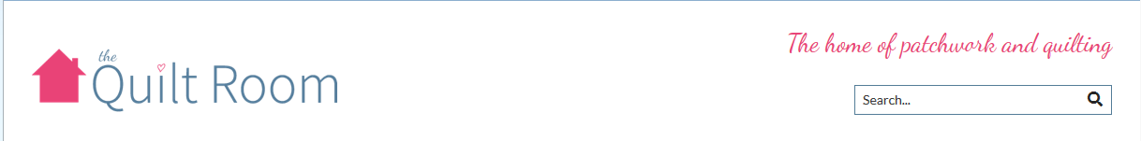

Font

NAV



POST-HEAD



SPLASH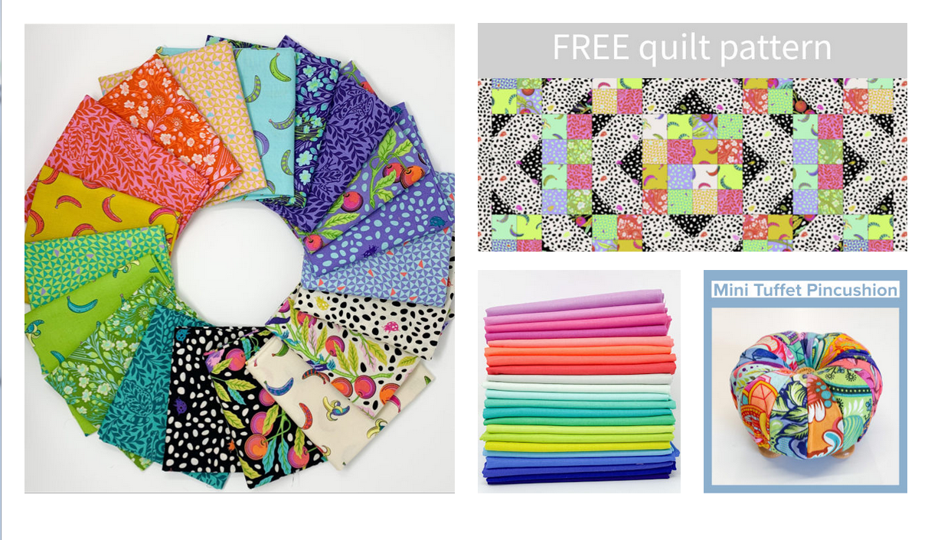

NEW

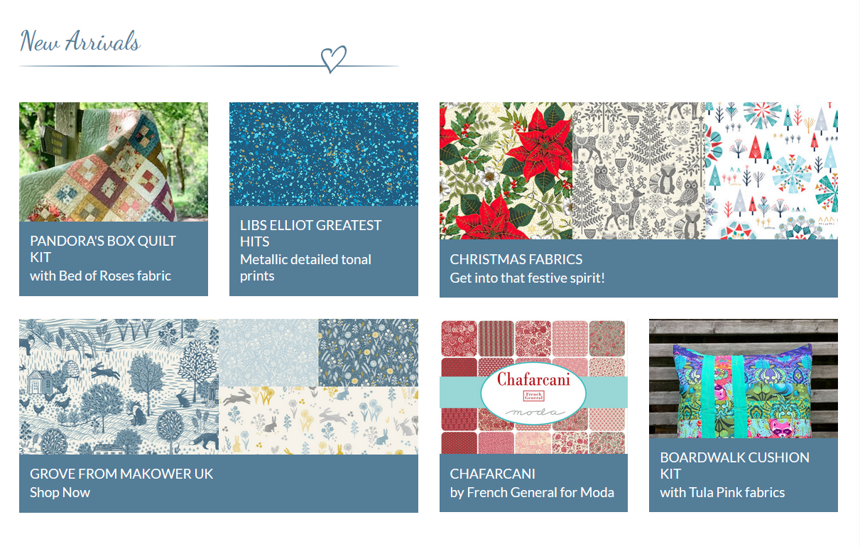

FEATURED

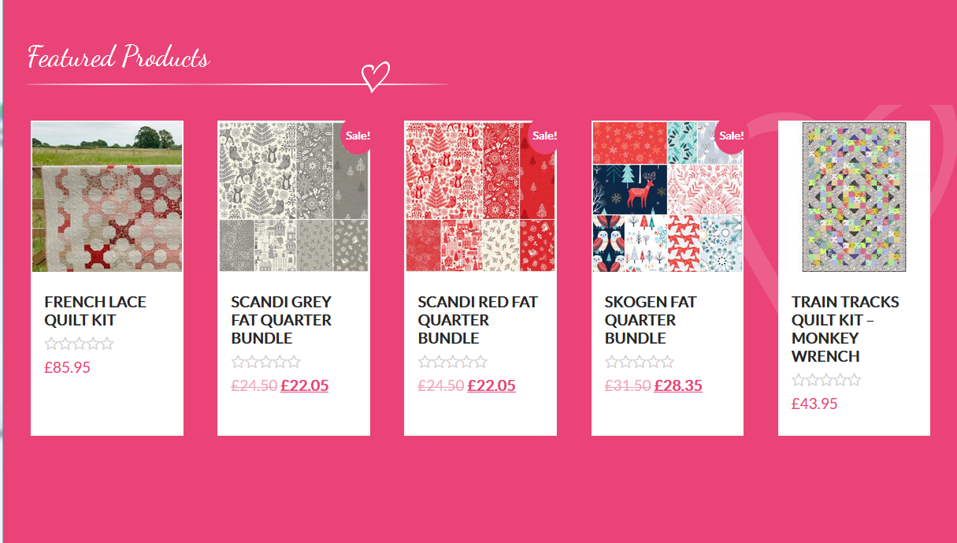

ABOUT

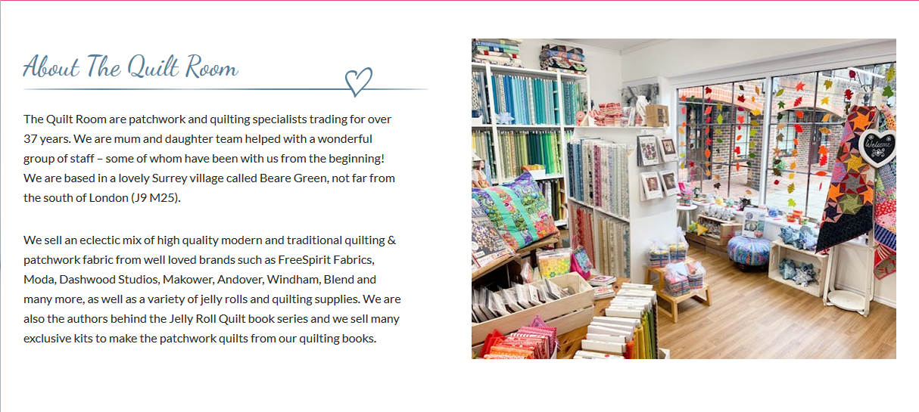

YOU

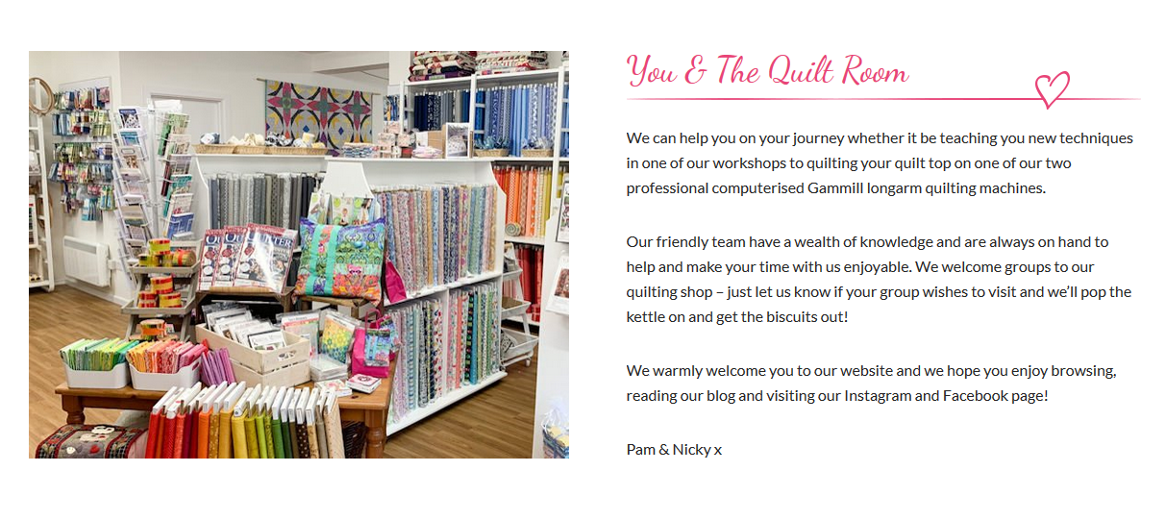

NEWSLETTER

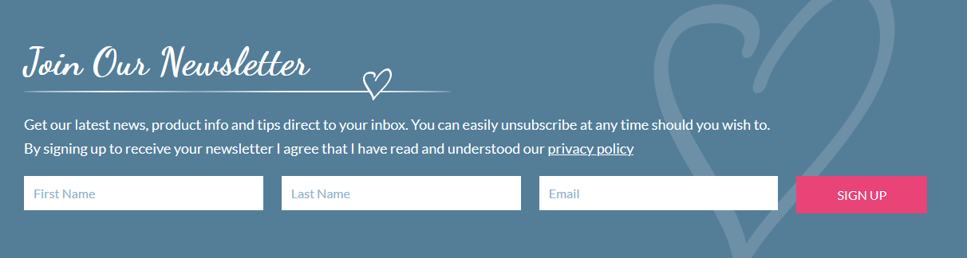

FOOTER

